Insert Organization
Name or Logo
Electronics Recycling Collection Fundraiser
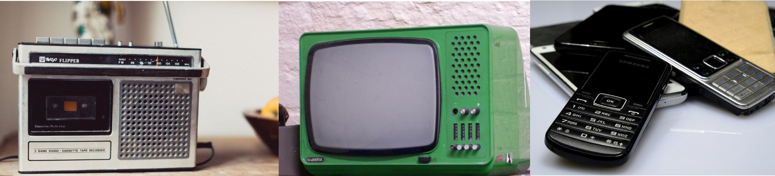

Date & Time
Location
Help us raise money for (insert cause/charity) by recycling your unwanted electronics!
We accept all electronics including: TVs, computers and laptops, cell phones, camera and AV equipment, household appliances large and small, and more!

